DDEX provider sample for the ADO.NET Entity Designer

1. Introduction 2
1.1 ADO.NET Entity Designer, EF providers and DDEX 2
1.2 Generate a model from a database 2
1.3 Validate model and mappings 7
1.4 Update Model from Database 7
2. Example.ExtendedProvider DDEX sample 8
2.1 Overview 8
2.2 Changes to the Example.ExtendedProvider sample 8
2.3 Building the sample 8
2.4 Unregistering the sample DDEX provider 9
2.5 Running and testing 9
2.5.1 End to end wizard test 10
2.5.2 Sample test app 12

Introduction
The ADO.NET Entity Framework has an extensible provider architecture that lets 3rd party data sources participate in the Entity Framework (EF).
This document describes how 3rd party Entity Framework providers can plug-in into the ADO.NET Entity Framework Designer design time experience in Visual Studio 11.

ADO.NET Entity Designer, EF providers and DDEX
The ADO.NET Entity Designer leverages the EF provider framework and Data Designer Extensibility (DDEX) providers in Visual Studio 11. More information about DDEX can be found at Getting Started (DDEX) on MSDN. The ADO.NET Entity Designer uses public DDEX APIs to discover and work with providers.
We recommend that that you create, debug and get your EF provider up & running before integrating with the ADO.NET Entity Designer and DDEX. Assuming your EF provider is available, here’s a summary of how to plug into the ADO.NET Entity Designer:
- Strong name sign and deploy your EF provider to the GAC
- Extend your existing DDEX provider or create a new DDEX provider by extending the sample Example.ExtendedProvider DDEX sample or as described in Getting Started (DDEX) on MSDN.
- Set the InvariantName in the DDEX provider registration to your EF provider as per the sample Example.ExtendedProvider DDEX sample or as described DDEX Provider Registration on MSDN.
- Register the DDEX provider with Visual Studio as per the sample Example.ExtendedProvider DDEX sample or as described in Registering a Non-Package-Based DDEX Provider on MSDN.
Assuming the EF and DDEX providers are available, working and registered correctly, ISVs can seamlessly plug into the ADO.NET Entity Designer experience for generating models from a database, mapping and validation with a few minor changes to their existing DDEX provider.
The key point here is that if your EF provider is working correctly then the bar to create a DDEX provider is fairly low and well documented on MSDN. Apart from having a DDEX provider, the EF provider does not need to do anything special to plug into the ADO.NET Entity Designer design time experience.
In case you are interested in learning more, the Visual Studio 11 SDK has lots of useful information about DDEX.

Generate a model from a database
This section describes a typical designer walkthrough and identifies the places where the ADO.NET Entity Designer wizard interacts with public APIs in DDEX and the EF provider.
When a new “ADO.NET Entity Data Model” is added to a project, the ADO.NET Entity Designer displays a wizard that lets users choose whether to create a model from a database or start with an empty model as shown in the picture below:
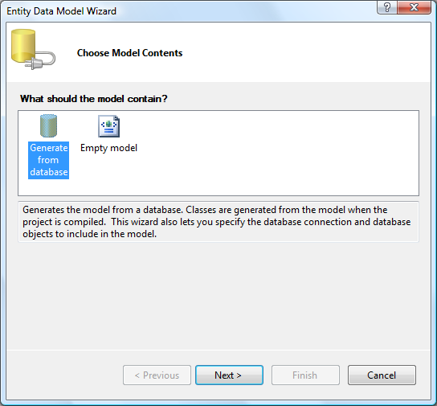
Choosing “Generate from database” lets users choose an existing connection or create a new connection as shown in the following picture:
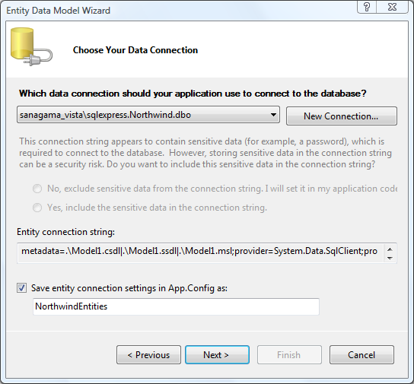
The ADO.NET Entity Designer uses public DDEX APIs to list available connections. Clicking the “New Connection” button displays the standard Visual Studio dialog where users can choose a different data source and also specify a DDEX provider to use for the data source:

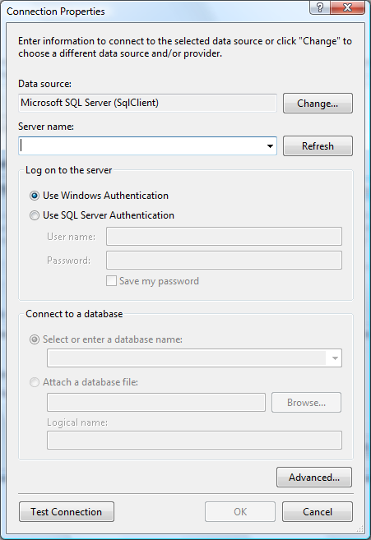
Clicking the “Change” button in this dialog displays the standard Visual Studio dialog with a list of data sources and the DDEX data providers available for the selected data source.
The ADO.NET Entity Designer examines all registered DDEX data sources and only shows those that have EF enabled DDEX data providers (i.e. DDEX data providers with an InvariantName that specifies an EF provider). Note that DDEX allows you to register multiple “EF enabled” DDEX data providers for the same data source and the ADO.NET Entity Designer will show all of these.
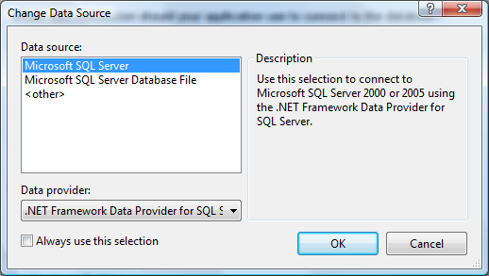
For example, the Microsoft SQL Server data source has a DDEX data provider called .NET Framework Data Provider for SQL Server which has a corresponding Entity Framework runtime provider registered for it.
Choosing a data source and data provider and clicking “OK” brings the user back to the “Connection Properties” dialog where the user can specify additional connection properties like authentication, initial catalog and database. Other advanced provider-specific properties can be specified by clicking the “Advanced” button.
Clicking “OK” on the “Connection Properties” dialog creates a new connection in Server Explorer and brings the user back to the “Choose Your Data Connection” wizard page. The ADO.NET Entity Designer retrieves the provider connection using public DDEX APIs and updates the Entity Connection string in the wizard GUI. The value returned by IVsDataConnection.DisplayConnectionString is used for display proposes.
Clicking “Next” on the “Choose Your Data Connection” wizard page displays the tables, views and stored procedures as shown in the following picture:
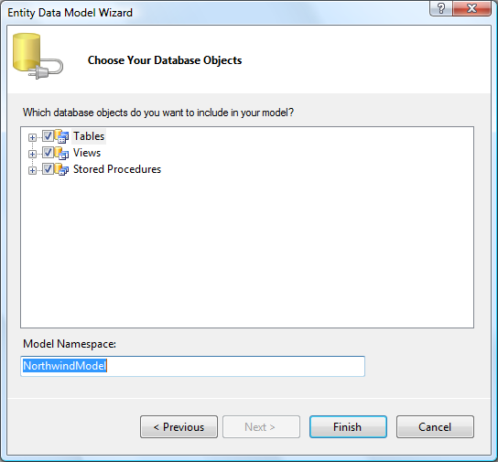
The ADO.NET Entity Designer calls the public model generation APIs in System.Data.Entity.Design.dll to obtain information shown on this wizard page. These public model generation APIs internally call a number of public APIs implemented in the EF provider (including GetStoreSchemaDescription and GetStoreSchemaMapping).
Thus, the information shown in the wizard GUI comes directly from the EF provider. The wizard lets users select which tables, views and stored procedures to include in the model, and clicking “Finish” causes the ADO.NET Entity Designer to call the EF public model generation APIs again to generate the new model (with filters for objects selected by the user).
Finally, the ADO.NET Entity Designer also adds the Entity Connection String to Web.Config (for ASP.NET web site and web app projects) and App.Config (for other project types) as shown below:
<connectionStrings>
<add name="NorthwindEntities"
connectionString="metadata=res://*/Model1.csdl|res://*/Model1.ssdl|res://*/Model1.msl;provider=System.Data.SqlClient;provider connection string=&quot;Data Source=.\sqlexpress;Initial Catalog=Northwind;Integrated Security=True;MultipleActiveResultSets=True&quot;" providerName="System.Data.EntityClient" />
</connectionStrings>

In the above entity connection string, the yellow text is the invariant name obtained from the DDEX provider registration and the grey text is the provider connection string obtained from DDEX. The exact contents of the provider connection string depend on what the user chose in the “Connection Properties” DDEX dialog.

Validate model and mappings
Users can validate the model and mappings in the ADO.NET Entity Designer to detect inconsistencies in the model and mappings at design time. Users can validate via a context menu on the designer surface and the validation process will report inconsistencies in the model & mappings as errors in the Visual Studio error window. Double-clicking on an error selects the offending shape or connector on the design surface where users can intuitively fix the errors.
The ADO.NET Entity Designer leverages public APIs in the Entity Framework to validate the model and mappings. These public validation APIs internally call public methods implemented by the provider.
The ADO.NET Entity Designer determines the provider to use from the Entity Connection string in App / Web.config. If an Entity Connection string is not found in App/Web.config, the ADO.NET Entity Designer displays the “Choose Your Data Connection” wizard page to let users select a connection to use. This is identical to the wizard experience described in Generate a model from a database described earlier.
Whether or not a connection is needed depends on the provider in question. For example, the EF provider for SQL Server does not need a connection to validate the model & mappings. If a connection is not available then the ADO.NET Entity Designer validates the model & mappings using the EF provider for SQL Server which may or may not be appropriate for your provider.
In order for validation scenarios to work from the designer in disconnected environments, we strongly recommend that a provider manifest be returned without the need for opening a database connection.

Update Model from Database
During iterative development, users typically generate a model and mappings from a database but also change the database later after the model was generated. Users can update the model & mappings to reflect the database via the “Update Model from Database” context menu available in the Entity Model Browser window in the ADO.NET Entity Designer.
The “Update Model from Database” functionality in the ADO.NET Entity Designer determines the provider to use from the Entity Connection string in App / Web.config. If an Entity Connection string is not found in App/Web.config, the ADO.NET Entity Designer displays the “Choose Your Data Connection” wizard page to let users select a connection to use. This is identical to the experience described in Generate a model from a database which leverages the same plug-in points for DDEX data providers and EF providers as described earlier.
If an appropriate Entity Connection string is found in App / Web.config then the “Update Model from Database” functionality shows the “Choose Your Database Objects” wizard page. Information in the wizard page is obtained by calling the public model generation APIs in System.Data.Entity.Design.dll. These public model generation APIs internally call a number of public APIs implemented in the EF provider (including GetStoreSchemaDescription and GetStoreSchemaMapping).
As before, the information shown in the wizard GUI comes directly from the EF provider. The wizard detects any new tables, views and stored procedures that are present in the database but not in the model and lets users select which to include. Clicking “Finish” calls the EF public model generation APIs, again with filters for objects selected by the user, and the results are merged into the existing model.
In addition, entities, relationships, etc., that are already in the model are refreshed to reflect what’s in the database.

Example.ExtendedProvider DDEX sample

Overview
The Visual Studio 11 SDK has a sample DDEX provider called “Example.ExtendedProvider” which is a new DDEX data provider for the SQL Server data source.
To illustrate how to create a DDEX provider that corresponds to the Entity Framework sample provider, we took the “Example.ExtendedProvider” sample from the Visual Studio 11 SDK and modified it slightly to work with the Entity Framework sample provider.
It is not necessary to install the Visual Studio 11 SDK to build and use the sample described here.

Changes to the Example.ExtendedProvider sample
We made the following changes to the “Example.ExtendedProvider” sample from the Visual Studio 11 SDK and included the modified version here. No other files were modified.
In project properties (right click on the ExtendedProvider project in the solution explorer and select Properties) on Application tab we made sure that Target Framework is set to .NET Framework 4.5.
File | Changes made
SqlObjectSelector.cs | - Added: using SampleEntityFrameworkProvider  - Added: using System.Data.Common  - Changed line #79 to use SampleConnection instead of SqlConnection  - Changed line #95 to use SampleCommand instead of SqlCommand  - Changed line #186 to use DbDataReader  - Commented out line #189 (no support for SqlCommandBuilder)
ExtendedProvider.reg | - Changed line #13 to specify "SampleEntityDDEXProvider"  - Changed line #18 to specify SampleEntityFrameworkProvider as the InvariantName  - Make sure versions of assemblies are 11.0.0.0
Properties\AssemblyInfo.cs | Changed AssemblyTitle and AssemblyProduct to indicate SampleEntityDDEXProvider
Properties\Resources.resx | Updated string resources Provider_Description, Provider_DisplayName and Provider_ShortDisplayName
Install.cmd | - Changed line #5 to echo  - Changed line #11 to point to 11.0Exp_Config
Install.vbs | - Removed & "\Configuration" from line #25

We also included the modified “Example.ExtendedProvider” project in the same solution as the EF sample provider to make building & debugging easier. We added a reference to the sample provider project.

Building the sample
Start Visual Studio 11 as Administrator and open the solution SampleEntityFrameworkProvider.sln and build the solution. Building the solution builds the sample EF provider, installs it into the GAC and also builds and registers the Example.ExtendedProvider sample.
DDEX registration is added to the main Visual Studio registry hive as part of a project post-build step in the Example.ExtendedProvider project.
NOTE: If you wish, you can modify the project post-build step to register in the Visual Studio Experimental hive to avoid affecting the main Visual Studio registry hive. More information on running Visual Studio in Experimental mode can be found here Visual Studio Experimental Build.
The DDEX provider GUID for the Example.ExtendedProvider sample is {E46DFA5C-80A2-4a7a-B6FC-C5D2F67D8690} and registration information is added to the registry in the following hive:
HKEY_LOCAL_MACHINE\SOFTWARE\Microsoft\VisualStudio\11.0_Config\DataProviders\{E46DFA5C-80A2-4a7a-B6FC-C5D2F67D8690}
In addition, the following registry key registers a mapping from the existing DDEX data source for Microsoft SQL Server to the sample provider as a supporting provider.
HKEY_LOCAL_MACHINE\SOFTWARE\Microsoft\VisualStudio\11.0_Config\DataSources\{067EA0D9-BA62-43f7-9106-34930C60C528}\SupportingProviders\{E46DFA5C-80A2-4a7a-B6FC-C5D2F67D8690}
NOTE: If you use experimental version replace 11.0_Config with 11.0Exp_Config

Unregistering the sample DDEX provider
To unregister the Example.ExtendedProvider DDEX sample, simply delete the following registry keys:
HKEY_LOCAL_MACHINE\SOFTWARE\Microsoft\VisualStudio\11.0_Config\DataProviders\{E46DFA5C-80A2-4a7a-B6FC-C5D2F67D8690}
and
HKEY_LOCAL_MACHINE\SOFTWARE\Microsoft\VisualStudio\11.0_Config\DataSources\{067EA0D9-BA62-43f7-9106-34930C60C528}\SupportingProviders\{E46DFA5C-80A2-4a7a-B6FC-C5D2F67D8690}
NOTE: If you use experimental version replace 11.0_Config with 11.0Exp_Config
NOTE: If desired, also remove the sample EF provider from the GAC by calling gacutil.exe from a Visual Studio Command Prompt as follows:
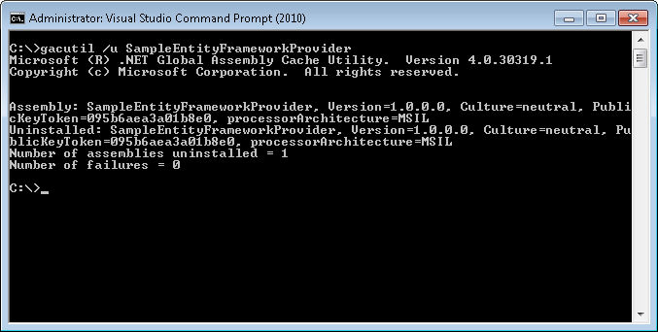

Running and testing
Using the Example.ExtendedProvider DDEX sample requires a one-time registration of the EF sample provider in machine.config.
Exit Visual Studio if it is running and manually edit the file %windir%\Microsoft.NET\Framework\v4.0.30319\CONFIG\machine.config as follows:
<configuration>
<!-- Existing entries -->

<system.data>
<DbProviderFactories>
<!-- Existing entries -->

<!-- Add the following line -->
<add name="Sample Entity Framework Provider"
invariant="SampleEntityFrameworkProvider"
description="Sample Entity Framework Provider"
type="SampleEntityFrameworkProvider.SampleFactory, SampleEntityFrameworkProvider, Version=1.0.0.0, Culture=neutral, PublicKeyToken=095b6aea3a01b8e0" />

</DbProviderFactories>
</system.data>

<!-- Existing entries -->

</configuration>

Note: Once you add the entry to machine.config, be sure to remove the corresponding app.config entry from projects that rely on the provider to prevent duplicate entries from resulting in a ConfigurationErrorsException.
Start Visual Studio and set the ExtendedProvider project as the startup project from Solution Explorer and press Ctrl+F5 to start without debugging. This will build the project if necessary and launch another instance of Visual Studio.
In the 2nd instance of Visual Studio, you can perform the following manual tests to verify that the sample DDEX provider and/or the sample EF provider are working properly. If you wish, you can also set breakpoints in the EF or DDEX provider code in 1st instance of Visual Studio.

End to end wizard test
In this basic test, we will use the Example.ExtendedProvider DDEX data provider to call into the sample Entity Framework provider to generate model and mappings from the Northwind database on a local instance of SQL Express.
This test also verifies that the DDEX provider is recognized by the ADO.NET Entity Designer model generation wizard
- Create a new Console Application project
- Right-click on the project in Solution Explorer and choose Add…New…Item
- Choose “ADO.NET Entity Data Model” from the list of items and click “Add” to launch the wizard
- In the “Choose Model Contents” page, choose “Generate from database” and click Next
- In the “Choose Your Data Connection” page, click “New Connection…”
- In the “Connection Properties” dialog, click “Change”
- In the “Change Data Source” dialog, select “Microsoft SQL Server”
- Verify that the “Data provider” list box shows the data provider “Sample DDEX provider for SampleEntityFrameworkProvider for SQL Server” as shown in the picture below:
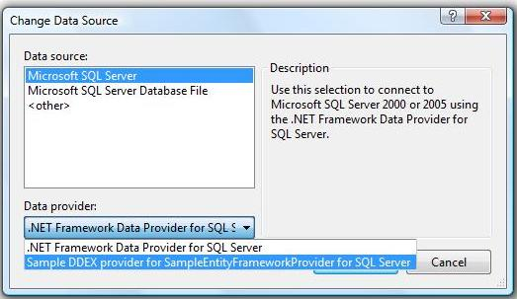
- Choose it and click OK and notice that the “Connection Properties” has changed to look like the following:
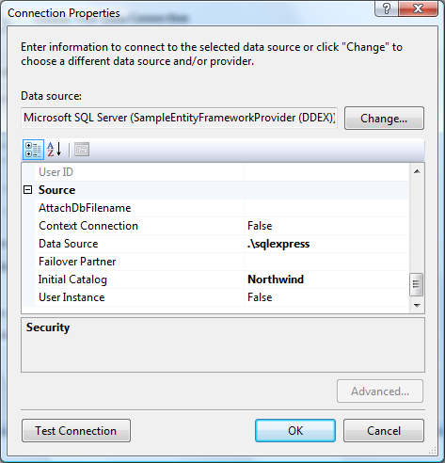
- Set the Data source property to .\SqlExpress
- Set the Initial Catalog property to Northwind
- Set the Integrated Security property to True
- If you want, click the “Test Connection” button to test your connection properties
- Click OK to accept your connection properties and go back to the “Choose Your Data Connection” page
- Click Next to go to the “Choose Your Database Objects” page.
If you had them, breakpoints in the GetStoreSchemaDescription and/or GetStoreSchemaMapping methods in the sample EF provider, should be hit when you clicked “Next”
- Check the desired tables, views and stored procedures and click “Finish”
- If you had them, breakpoints in GetStoreSchemaDescription and/or GetStoreSchemaMapping methods in the sample EF provider should be hit again when you clicked “Finish”
- The model and mappings are generated using the data obtained from the sample DDEX provider and the sample EF provider and the .edmx file is opened in the ADO.NET Entity Designer.
- Notice that the ADO.NET Entity Designer wizard added the following Entity Connection string to App.Config.
<configuration>
<connectionStrings>
<add name=”NorthwindEntities” connectionString="metadata=res://*/Model1.csdl|res://*/Model1.ssdl|res://*/Model1.msl;provider= SampleEntityFrameworkProvider;provider connection string=&quot;Data Source=.\sqlexpress;Initial Catalog=Northwind;Integrated Security=True&quot;” providerName=”System.Data.EntityClient” />
</connectionStrings>
</configuration>
connectionString="metadata=res://*/Model1.csdl|res://*/Model1.ssdl|res://*/Model1.msl;provider=System.Data.SqlClient;provider connection string=&quot;Data
As described earlier, the yellow text is the invariant name obtained from the DDEX provider registration and the grey text is the provider connection string obtained from DDEX “Connection Properties” dialog.
- There is no need to add an entry for <DbProviderFactories> in App.Config since the SampleEntityFrameworkProvider was added to machine.config earlier
Note that the sample DDEX provider (Example.ExtendedProvider) is only used at design time while the sample EF provider (SampleEntityFrameworkProvider) is used both at design time and at runtime. It is up to the provider writer to deploy them as necessary. Anything that is in App.Config is expected to be available at runtime.

Sample test app
This test extends the previous test by creating a simple console application that uses the ADO.NET Entity Framework APIs over the model & mappings generated by the wizard in the previous test. Specifically, it also verifies that the Entity Connection string in App.Config correctly loads the sample EF provider (SampleEntityFrameworkProvider) for CRUD operations.
- In the Console application from the previous test, double-click on Program.cs in Solution Explorer to open it
- Type the following source code (you may copy/paste the code if you wish):
class Program
{
static void Main(string[] args)
{
using (NorthwindModel.NorthwindEntities e = new NorthwindModel.NorthwindEntities())
{
foreach (NorthwindModel.Customers c in e.Customers)
Console.WriteLine(c.ContactName);
}
}
}

- Set a breakpoint on the line with the using statement
- Press F5 to build and debug the application
- When the breakpoint is hit, press F11 to step into the constructor for NorthwindEntities
- Continue pressing F11 and you should be able to step into the SampleFactory class in the SampleEntityFrameworkProvider.
- If you like, you can set additional breakpoints in the SampleEntityFrameworkProvider to see how the methods are called by the Entity Framework.
- Finally, press F5 to run the application and you should see a list of customer names scroll past in the console window
Exit the 2nd instance of Visual Studio when you are done debugging the sample providers.

